Verifying barcodes
- Universal product codes (UPC for short) are the little barcodes you find on basically any packaged item.
- When we view barcodes, we interpret them as thin or thick bars and wide or narrow gaps
  - The bars have four different widths:
    - Thicker bars being 2, 3, or 4 times the width of the thinnest bar
  - Similarly, the gaps also have 4 different widths:
    - Wider gaps being 2, 3, or 4 times the width of the thinnest gap
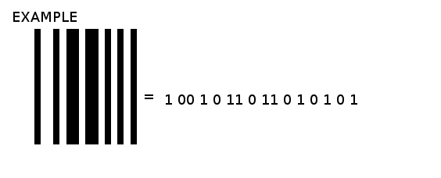
- Although they may not look like it, UPC’s are binary codes with 95 bits
- Each bar is a one while each gap is a 0
  - The width determines the amount of 0’s or 1’s
Example 1
- To verify a barcode, we must verify the modulo check character
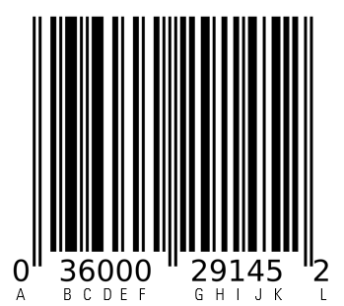
  - This is the last number in our barcode
- Assign each digit a letter A-L
- A BCDEF GHIJK L
- Now we calculate the following:
        - (3*(A + C + E + G + I + K) + (B + D + F + H + J)
        - (3*(0 + 6 + 0 + 2 + 1 + 5) + (3 + 0 + 0 + 9 + 4) = 58
- After calculating that we now want to subtract the number we got from the next highest multiple of 10
        - 60 – 58 = 2
Example 2
0 39402 01700 4

Example 3
0 14113 91002 6

Using R
- R can be used a calculator, so let’s plug in 2+3
- Instead of calculating that every time, we can store the answer in a variable
  - Use <- to save 2+3 in variable x
  - After doing this we must tell R to print it out by entering print(x)
- We are also able to store list of numbers. These are called vectors
  - To store the vector (3, 6, 9) in variable y, we need to use the c() function
  - y <- c(3, 6, 9)
- Sometimes we want to know the sum of the elements in our variable
  - Try inputting sum(y)
- Let’s do a sequence
  - Input seq(1, 12)
  - Also try seq(1, 12, by=2)
Example 4
Let’s try to solve this barcode on R:
0 36000 29145 2
- After storing the barcode, we want to start the process of solving:
  - (3*(A + C + E + G + I + K) + (B + D + F + H + J)
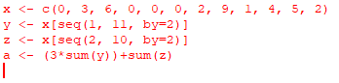
- We want to subtract the number we got from the next highest multiple of 10
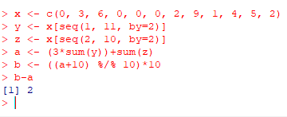
Try on R
- 0 98307 10048 9

- 0 17600 02177 9

