Theoretical Probability vs Experimental Probability
Theoretical Probability  What is likely to happen based on math  P(event) = $\frac{Number of favorable outcomes}{Total number of possible outcomes}$  Example:  A coin is tossed.  P(heads) = $\frac{1}{2}$  P(tails) = $\frac{1}{2}$ | Experimental Probability  Is found by repeating experiments and documenting the outcomes  P(event) = $\frac{Number of times event occured}{Total number of trials}$  Example:  A coin is tossed 10 times. A head is recorded 3 times and a tail is recorded 7.  P(heads) = $\frac{3}{10}$  P(tails) = $\frac{7}{10}$

We’re going to start with something easy to figure theoretical vs experimental!
Let’s figure out the theoretical probability of suits you could get!
 | 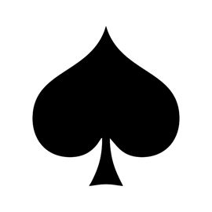
$$\frac{}{52}$$ | $$\frac{}{52}$$ | $$\frac{}{52}$$ | $$\frac{}{52}$$
Now, everyone will come up one by one, pick a card, show the suit of the card, tally which suit is picked, and shuffle the deck again. We will be experimenting to see the outcome.

Let’s figure out the theoretical probability of colors you could get!
Red | Black
$$\frac{}{52}$$ | $$\frac{}{52}$$

Now, everyone will come up one by one, pick a card, show the color, tally which color was picked, and shuffle the deck again. We will be experimenting to see the outcome.
Red | Black

Let’s try look at this another way! I will hand out 4 cards to 13 people. We will document the number of red vs black cards we all have on a number line. After doing this, we’ll make a bar graph to visualize these numbers.

Red Cards

Black Cards

